Group No. - 109
Student Name | Student Id
Volam Abhiraj | 2024AA05622
Deepti Prashant | 2024AB05171
Krishna kumar | 2024AA05240
Ginny George | 2024AA05275

GitHub Repository: https://github.com/deepp11/heart-disease-mlops.git
Project Overview
- Developed an end-to-end heart disease classification system using the UCI Heart Disease dataset with 14 clinical features and a binary target (disease vs no disease).
- Implemented a complete MLOps pipeline including data acquisition, preprocessing, model training with experiment tracking, CI/CD, containerization, Kubernetes deployment, and monitoring.

Setup and Installation
- Project is organized under content/mlops-heart-disease with subdirectories for src, api, docker, k8s, helm, monitoring, tests, and mlruns (MLflow artifacts).
- A single requirements file (requirements.txt) is generated for the Docker/API environment, including FastAPI, Uvicorn, scikit-learn, pandas, numpy, joblib, prometheus-client, and utilities such as httpx and python-multipart.
Typical setup steps:
## 📁 Project Structure
- `app/` - FastAPI application
- `deployment/` - Docker & Kubernetes configs
- `MLOps/` - Machine learning code
- `Dockerfile` - Container definition
- `requirements.txt` - Dependencies

## ⚡️ Clone, setup, test, and deploy
- git clone https://github.com/deepp11/heart-disease-mlops.git
- cd heart-disease-mlops
- pip install -r requirements.txt
- ./run-api.sh & # Run in background
- sleep 5 # Wait for API to start
- ./quick_test.sh # Run tests
- ./simulate_load_balancer.sh # to simulate load balancer

## 🌐 API Endpoints
- Health: `curl http://localhost:8000/health`
- Docs: http://localhost:8080/docs

EDA and Modelling Choices
- Data loading and cleaning are encapsulated in src/dataacquisition.py, which downloads the UCI Heart Disease CSV, handles missing values, and ensures a clean DataFrame for the pipeline.
- A preprocessing pipeline (HeartDiseasePreprocessor in src/preprocessing.py) performs:
  - Separation of numeric and categorical features.
  - Imputation with SimpleImputer and scaling with StandardScaler for numeric columns, plus encoding and imputation for categoricals, all wrapped in a ColumnTransformer and Pipeline.
- The function preparedatafortraining:
  - Splits data into train/validation/test with stratification and separate test and validation ratios.
  - Fits the preprocessing pipeline on training data and transforms train/val/test into X_train_processed, X_val_processed, X_test_processed, returning them along with y arrays and the preprocessor object.
- Model development (src/train.py) includes:
  - Multiple classifiers: Logistic Regression, Random Forest, Gradient Boosting, and SVM with predefined hyperparameter grids (C, penalty, solver for Logistic Regression; n_estimators, max_depth, min_samples_split for Random Forest; n_estimators, max_depth, learning_rate for Gradient Boosting; and kernel/C/gamma for SVC).
  - GridSearchCV with ROC-AUC scoring, cross-validation, and selection of the best estimator per model type, followed by test-set evaluation with accuracy, precision, recall, f1-score, and ROC-AUC.
Include in your report:
- Rationale for using ROC-AUC as the primary metric (class-imbalance and ranking quality).
- Plots saved by training code: confusion matrix, ROC curve, and feature importance for tree-based models, stored as artifacts and logged to MLflow runs.

Experiment Tracking Summary
- MLflow is configured with a tracking URI mlruns and experiment name heart-disease-classification in src/train.py.
- For each model type:
  - A new MLflow run is started, tagged with modeltype and cvfolds.
  - Grid search best parameters are logged via mlflow.log_params, and cross-validation statistics (cv_mean_roc_auc, cv_std_roc_auc) are logged as metrics.
  - Test metrics (test_accuracy, test_precision, test_recall, test_f1score, test_rocauc) are logged using mlflow.log_metric.
  - Artifacts logged include confusion matrix image, ROC curve image, feature importance plot (for tree models), and a textual classification report.
  - The best model is serialized as an MLflow model artifact with mlflow.sklearn.log_model and also saved locally under models/<model_name>/model.joblib.
- A separate function selectbestmodel scans the results dictionary and selects the model with the greatest ROC-AUC, which is then combined with the preprocessor and saved as a deployment package (models/bestmodel.joblib or modelpackage/models/fullmodelpackage.joblib).In your report, summarize:
- Number of experiments (different model families, hyperparameter grid sizes).
- Which model was chosen as best by ROC-AUC and where its MLflow run can be found in mlruns/.

Architecture and System Design
- High-level architecture (describe or draw diagram in report):
  - Data acquisition/cleaning module → preprocessing module → training module with MLflow tracking → model package (model + preprocessor) → FastAPI serving container → Kubernetes deployment → monitoring stack with Prometheus and Grafana.
- Training & packaging flow:
  - dataacquisition.loadandcleandata → preprocessing.preparedatafortraining → train.trainallmodels → train.selectbestmodel → train.savebestmodel creates a portable deployment package used by the API.
- Serving architecture:
  - FastAPI app (api/main.py) loads the combined model-preprocessor package on startup from one of several candidate paths (app/models/fullmodelpackage.joblib, content/mlops-heart-disease/modelpackage/models/fullmodelpackage.joblib, etc.).
  - API exposes endpoints: / (root info), /health, /modelinfo, /metrics, /predict, /predictbatch, with pydantic schemas PatientData, PredictionResponse, batch request/response models.
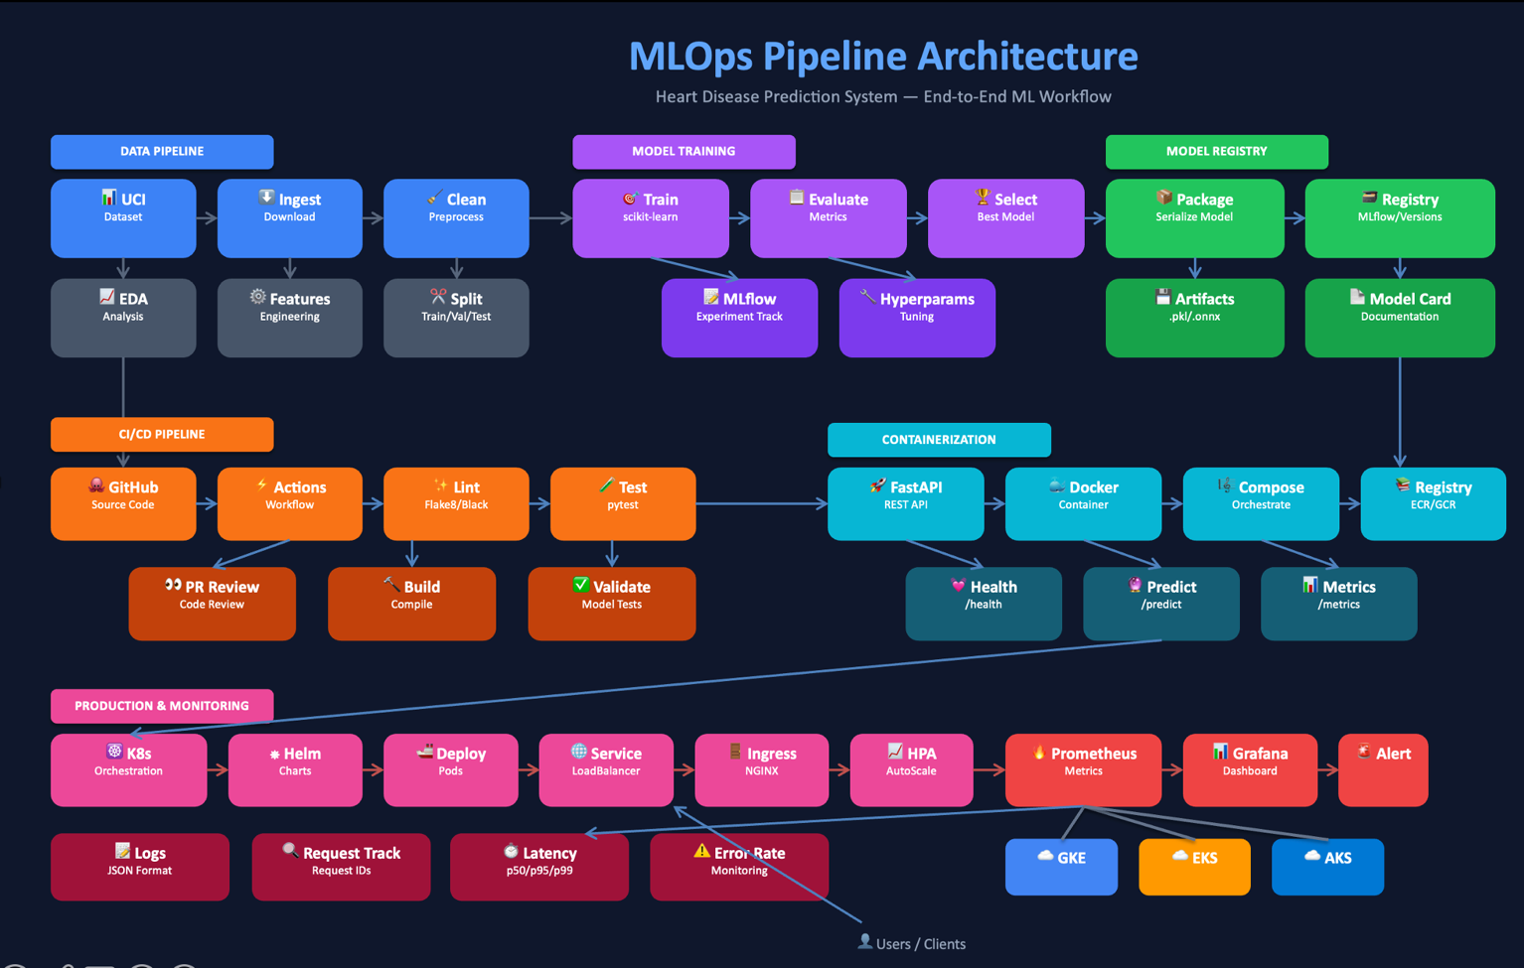
- Infrastructure & deployment:
  - Dockerfile under docker/Dockerfile (also copied to project root) uses python:3.10-slim, installs dependencies, copies api, src, models, and modelpackage, sets appuser, defines HEALTHCHECK for /health, and runs uvicorn api.main:app on port 8000.
  - docker-compose.yml defines api service and optional prometheus and grafana services under a custom mlops-network, mounting model volumes read-only and wiring health checks.
  - Kubernetes manifests under k8s (base + overlays) plus a Helm chart helm/heart-disease-api provide deployment, service, config, ingress, and environment configuration for running the API on Minikube or cloud clusters.

CI/CD, Testing, and Deployment Evidence
- Testing and quality gates:
  - Unit tests for data processing (tests/unittest_dataprocessing.py), model (tests/unittest_model.py), and API (tests/unittest_api.py).
  - Integration test for end-to-end pipeline (tests/integration/test_pipeline.py) and pytest configuration (pytest.ini, tests/conftest.py).
  - Linting and formatting with Flake8, Black, and isort configured via .flake8 and pyproject.toml.
- CI/CD workflows (.github/workflows):
  - ci-cd-pipeline.yml runs on push/PR:
    - Install dependencies, run linting (Flake8, Black, isort), run tests (pytest), run model training steps, build Docker image, and archive artifacts/logs.
  - test.yml focuses on unit/integration testing across the codebase.
  - model-validation.yml validates models (e.g., thresholds for metrics) before promoting them.
- Containerization and local deployment scripts:
  - build.sh builds the Docker image heart-disease-api:latest and prints run/test commands.
  - run.sh runs the container on port 8000, with health check instructions and log commands.
  - testapi.sh uses curl to hit /health, /modelinfo, and /predict with sample JSON.
Include screenshots of:
- GitHub Actions runs for CI/CD showing successful workflows, failed runs for demonstration of gating, and artifact/log views.MLOPS_Assign1-2.pdf+1

Monitoring, Logging, and Documentation Assets
- Logging and monitoring modules:
  - monitoring/logging/logger.py sets structured JSON logs with correlation IDs and request metadata.
  - monitoring/prometheus/metrics.py defines application-level metrics:
    - httprequeststotal, httprequestdurationseconds, modelpredictionstotal, modelpredictiondurationseconds, modelpredictionprobability, healthcheckstatus, apierrorstotal.
- Monitoring stack:
  - Docker Compose monitoring file monitoring/docker-compose.yml launches Prometheus, Grafana, and Alertmanager, wired to scrape the API’s /metrics endpoint.
  - Prometheus config monitoring/prometheus/prometheus.yml and alert rules monitoring/prometheus/alertrules.yml set up scraping of the API job and alerts (APIDown, HighErrorRate, HighLatency, HighPredictionLatency, HealthCheckFailing).
  - Grafana dashboard JSON monitoring/grafana/dashboards/heart-disease-api.json defines panels for total requests, predictions, health status, p95 latency, request/prediction rates, prediction distribution, latency percentiles, and error rates.
- Monitoring documentation and samples:
  - monitoring/README.md documents how to start the monitoring stack (./start-monitoring.sh), where to access Prometheus and Grafana, example PromQL queries, and notes on Kubernetes monitoring via monitoring/kubernetes/monitoring.yaml (ServiceMonitor & PrometheusRule).
  - monitoring/logging/samplelogs.txt provides example structured logs for inclusion in the report.
In the report, add:
- Screenshot of Grafana dashboard, Prometheus target status, and an example alert (even if simulated).
- Example JSON log line from samplelogs.txt illustrating correlation IDs and metrics.

Final Summary Report
============================================================
📋 FINAL SUMMARY REPORT
============================================================

📁 DATASET OVERVIEW:
• Source: UCI Heart Disease Dataset (ID: 45)
• Original samples: 303
• Cleaned samples: 297
• Features: 20 (after preprocessing)
• Target: Binary (0=No Disease, 1=Disease)

⚙️ PREPROCESSING STEPS COMPLETED:
1. Loaded data from UCI repository
2. Checked for missing values (-9 coded and NaN)
3. Created binary target variable
6. Encoded 8 categorical features
7. Scaled 5 numerical features
8. Split data: 237 train, 60 test samples

📊 KEY FINDINGS FROM EDA:
• Class Distribution: 137 with disease, 160 without (46.1% prevalence)
• Most Important Features (based on correlation):
1. oldpeak: +0.424 correlation
2. age: +0.227 correlation
3. trestbps: +0.153 correlation
• Data Quality: 297 clean samples ready for modeling
• Feature Matrix: 20 features for ML algorithms

💾 DATA READY FOR MODELING:
• X_train shape: (237, 20)
• X_test shape: (60, 20)
• y_train shape: (237,)
• y_test shape: (60,)

✅ ANALYSIS COMPLETE - Dataset is ready for machine learning!

======================================================================
🔢 MODEL 1: LOGISTIC REGRESSION
======================================================================

🔍 HYPERPARAMETER TUNING
----------------------------------------
Performing Grid Search with 5-fold CV...
✅ Tuning completed!

📊 Best Parameters:
C: 1
max_iter: 1000
penalty: l2
solver: saga
Best CV ROC-AUC: 0.8991

📈 TEST SET EVALUATION
----------------------------------------
Accuracy : 0.8000
Precision : 0.8333
Recall : 0.7143
F1-Score : 0.7692
ROC-AUC : 0.9297

📊 5-Fold Cross-Validation ROC-AUC: 0.8991 (±0.0720)

======================================================================
🌲 MODEL 2: RANDOM FOREST CLASSIFIER
======================================================================

🔍 HYPERPARAMETER TUNING
----------------------------------------
Performing Grid Search with 5-fold CV...
✅ Tuning completed!

📊 Best Parameters:
max_depth: None
max_features: sqrt
min_samples_leaf: 2
min_samples_split: 5
n_estimators: 100
Best CV ROC-AUC: 0.8961

📈 TEST SET EVALUATION
----------------------------------------
Accuracy : 0.7833
Precision : 0.8000
Recall : 0.7143
F1-Score : 0.7547
ROC-AUC : 0.9152

📊 5-Fold Cross-Validation ROC-AUC: 0.8961 (±0.0558)

======================================================================
📝 MODEL SELECTION & DOCUMENTATION
======================================================================

MODEL SELECTION RATIONALE:
1. Logistic Regression:
• Chosen as baseline model for interpretability
• Provides probability scores
• Linear decision boundary suitable for initial assessment

2. Random Forest:
• Chosen for comparison with non-linear capabilities
• Handles feature interactions automatically
• Robust to outliers and feature scaling

HYPERPARAMETER TUNING PROCESS:
• Used GridSearchCV with 5-fold stratified cross-validation
• Primary optimization metric: ROC-AUC
• Tuned key parameters for each model family
• Selected best parameters based on cross-validation performance

EVALUATION METRICS:
• Accuracy: Overall correctness
• Precision: Important for medical diagnosis (avoid false positives)
• Recall: Important for screening (avoid false negatives)
• F1-Score: Balanced measure of precision and recall
• ROC-AUC: Overall discriminative ability

🏆 FINAL MODEL RECOMMENDATION
----------------------------------------
Logistic Regression weighted score: 0.8038
Random Forest weighted score: 0.7895

✅ RECOMMENDED MODEL: Logistic Regression
Reasons:
1. Better weighted performance score
2. More interpretable coefficients
3. Simpler model with comparable performance

======================================================================
✅ MODEL DEVELOPMENT COMPLETED
======================================================================

💾 Models saved as 'final_logistic_regression.pkl' and 'final_random_forest.pkl'

======================================================================
🔬 MLFLOW EXPERIMENT TRACKING
======================================================================

📂 SETTING UP MLFLOW
----------------------------------------
✅ Experiment: Heart_Disease_Classification
📁 Tracking URI: file:./mlruns

📊 LOADING DATA
----------------------------------------
✅ Data loaded successfully!
Training samples: 237, Features: 20
Test samples: 60

======================================================================
🧪 EXPERIMENT 1: LOGISTIC REGRESSION
======================================================================

🏃 Running: LR_Default
2026/01/05 15:52:19 WARNING mlflow.models.model: `artifact_path` is deprecated. Please use `name` instead.
✅ Logged: Accuracy=0.800, ROC-AUC=0.929
📊 Run ID: c818d00197af493687d2669a03de3e09

🏃 Running: LR_StrongReg
2026/01/05 15:52:24 WARNING mlflow.models.model: `artifact_path` is deprecated. Please use `name` instead.
✅ Logged: Accuracy=0.817, ROC-AUC=0.908
📊 Run ID: 9ba9becedbf2417d8e987f5f597ef840

🏃 Running: LR_L1Reg
2026/01/05 15:52:26 WARNING mlflow.models.model: `artifact_path` is deprecated. Please use `name` instead.
✅ Logged: Accuracy=0.800, ROC-AUC=0.919
📊 Run ID: df04448302a9485d86a63a84bdafe33b

🏃 Running: LR_WeakReg
2026/01/05 15:52:28 WARNING mlflow.models.model: `artifact_path` is deprecated. Please use `name` instead.
✅ Logged: Accuracy=0.833, ROC-AUC=0.935
📊 Run ID: e50bcc158a6b48a2b5c2dfb7f50da179

======================================================================
🧪 EXPERIMENT 2: RANDOM FOREST
======================================================================

🏃 Running: RF_Default
2026/01/05 15:52:31 WARNING mlflow.models.model: `artifact_path` is deprecated. Please use `name` instead.
✅ Logged: Accuracy=0.850, ROC-AUC=0.910
📊 Run ID: 3c1f31fba7154425b12c2eebdd3f69e4

🏃 Running: RF_Shallow
2026/01/05 15:52:34 WARNING mlflow.models.model: `artifact_path` is deprecated. Please use `name` instead.
✅ Logged: Accuracy=0.833, ROC-AUC=0.917
📊 Run ID: 1fe71d6d04e949618c6a398d8f397f47

🏃 Running: RF_Deep
2026/01/05 15:52:37 WARNING mlflow.models.model: `artifact_path` is deprecated. Please use `name` instead.
✅ Logged: Accuracy=0.833, ROC-AUC=0.907
📊 Run ID: a65d52225f604a6c96d40ad6b9baf08e

🏃 Running: RF_Conservative
2026/01/05 15:52:42 WARNING mlflow.models.model: `artifact_path` is deprecated. Please use `name` instead.
✅ Logged: Accuracy=0.817, ROC-AUC=0.917
📊 Run ID: 3b1dbe93edf54c46a8c447b7c199958e

======================================================================
🧪 EXPERIMENT 3: GRID SEARCH TUNING
======================================================================

🏃 Running: GridSearch_RandomForest
2026/01/05 15:52:55 WARNING mlflow.models.model: `artifact_path` is deprecated. Please use `name` instead.
✅ Best params: {'max_depth': None, 'min_samples_leaf': 2, 'min_samples_split': 5, 'n_estimators': 100}
📈 Best CV score: 0.8961
🎯 Test ROC-AUC: 0.9152
📊 Run ID: e64a8e86f9db4126ae7d7fde8d20f27c

======================================================================
📊 EXPERIMENT SUMMARY
======================================================================

📈 TOP 5 RUNS BY ROC-AUC:
--------------------------------------------------------------------------------
Run Name Model Type ROC-AUC Accuracy F1-Score Run ID
--------------------------------------------------------------------------------
LR_WeakReg linear_models 0.9353 0.8333 0.8148 e50bcc158a6b48a
LR_Default linear_models 0.9286 0.8000 0.7692 c818d00197af493
LR_L1Reg linear_models 0.9185 0.8000 0.7600 df04448302a9485
RF_Conservative ensemble_models 0.9174 0.8167 0.7925 3b1dbe93edf54c4
RF_Shallow ensemble_models 0.9174 0.8333 0.8148 1fe71d6d04e9496

Repository Link and Final Report Structure
The assignment asks for:
- GitHub repository link containing:
  - src/, api/, docker/, k8s/, helm/, monitoring/, tests/, mlruns/, Dockerfiles,

